Park Hall Infant Academy
Nursery Curriculum Overview
 | Autumn 1  (Stage 1) | Autumn 2  (Stage 2) | Spring 1  (Stage 3) | Spring 2  (Stage 4) | Summer 1  (Stage 5) | Summer 2  (Stage 6)
Starting Point | Marvellous Me | Journey into Space | A Walk into the Wild | Once Upon a Time | What is in the garden? | Little Globetrotters: A Summer Around the World
Key Texts | 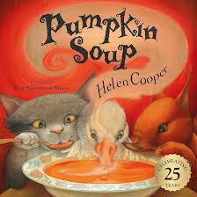  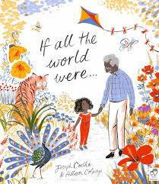  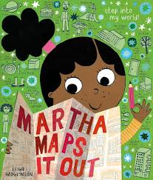  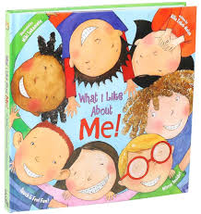  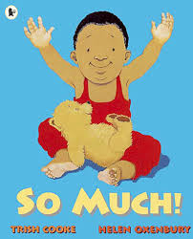 |   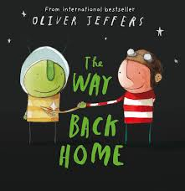  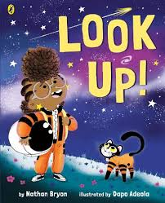  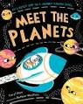  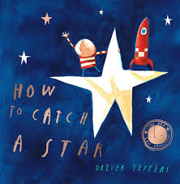 | 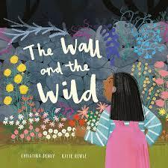  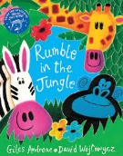  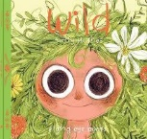  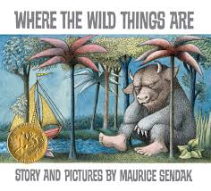  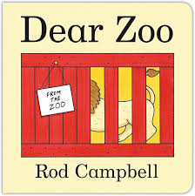 | 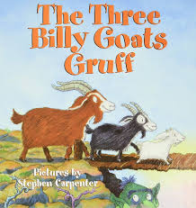  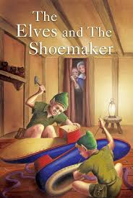  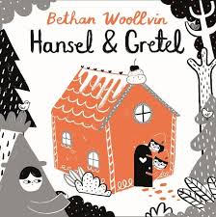  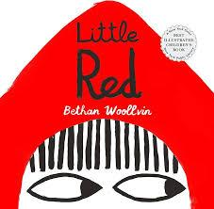  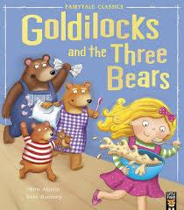 | 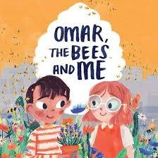  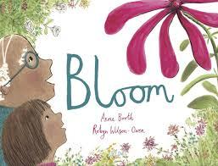  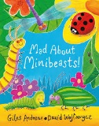  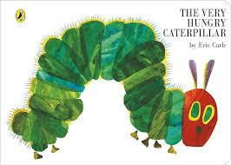  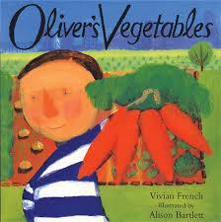  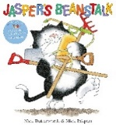 | 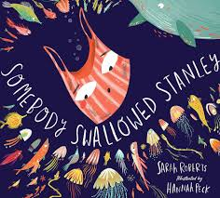  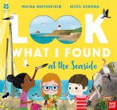  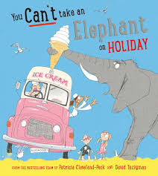  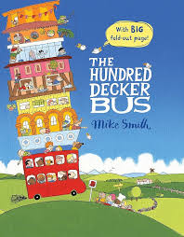  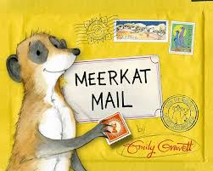
Poems and Lyrics Texts | 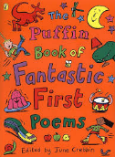 | 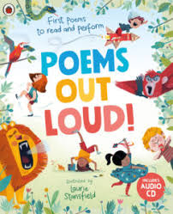 | 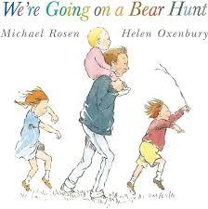 | 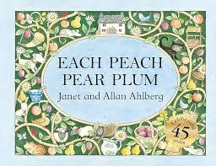 | 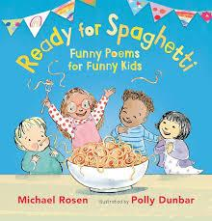 | 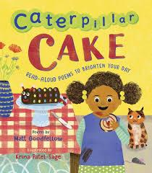
Online Safety | 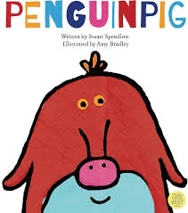 | 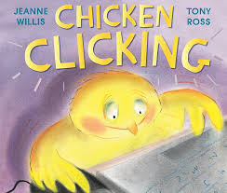 |  |  | 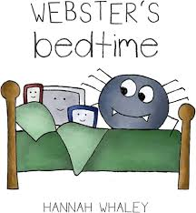 | 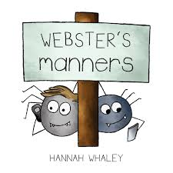
Songs and Rhymes | Autumn Leaves  Dingle Dangle Scarecrow | Zoom, Zoom, Zoom  Twinkle Twinkle | Teddy Bear’s Picnic  Walking Through the Jungle  Down in the Jungle | Hot Cross Buns  Humpty Dumpty  Jack and Jill | Wiggly Woo  Mary Mary Quite Contrary  Incy Wincy Spider  The Ants Go Marching  Little Miss Muffet | Concert songs
Curriculum Enhancements |  |  |  | Freshwater Theatre Company – Story Hunt
Role Play | Home Corner | Hot Chocolate Stand  Elf Workshop | Cave/Forest  Camping | Three Bears Cottage | Farmer’s Market/Garden Centre | Travel Agents/Airport
PSED  Self-regulation  Managing Self  Building Relationships | To seek comfort from familiar adults when needed.  To express their own feelings such as sad, happy, cross, scared and worried.  To separate from main carer with support and encouragement from a familiar adult.  To begin to show interest in others play and start to join in.  To begin to share experiences with others. | To begin to understand how others might be feeling.  To respond to the feelings and wishes of others.  To begin to show the ability to wait e.g. turn taking in play.  To express own preferences and interests.  To increasingly follow rules, understanding why they are important.  To demonstrate fondness and concern for people who they care for.  To pursue others to share ideas and to involve them in their activity. | To talk about their feelings using words like ‘happy’, ‘sad’, ‘angry’.  To be aware that some actions can hurt or harm others.  To select and use activities and resources, with help when needed. This encourages them to achieve a goal.  To appreciate and value praise for what they have done.  To begin to form a special friendship with another child/children.  To show more confidence in new social situations.  To play with a group of children beginning to extend the play. | To begin to inhibit own actions/behaviours, e.g. stop themselves from doing something they should not.  To begin to show signs of adapting to different environments.  To develop their sense of responsibility and belonging to a community.  To not always need an adult to remind them of a rule.  To share ideas of play with peers and lead play.  To keep play going by responding to what others are saying or doing. | To begin to show signs of adaptations to different social situations.  To begin to demonstrate the ability to distract self when upset, e.g. by engaging in a new play activity.  To become more outgoing with unfamiliar people, in the safe context of their setting.  To demonstrate friendly behaviour, initiating conversations and forming good relationships with familiar peers and adults. | To be aware of own feelings and know that some actions and words can hurt others feelings.  To understand that wishes cannot always be met.  To begin to develop appropriate ways of being assertive.  To begin to help to find solutions to conflicts and oppositions.
Communication and Language  Listening, attention and understanding  Speaking | To listen with interest to the noises adults make when they read stories.  To begin to distinguish and respond to familiar sounds e.g. a phone ringing.  To recognise action words by pointing to the right picture e.g. ‘Who is sleeping?’  To use gestures and single words to communicate.  To learn new words rapidly and use them when communicating. | To show interest in play with sounds, songs and rhymes.  To begin to pay attention to more than one thing at a time.  To begin to understand more complex sentences.  To begin to have an understanding of simple concepts e.g. hot, cold, big, little.  To start a conversation with an adult or a friends and continue it to have a back and forth interaction.  To use gestures, sometimes with small phrases to communicate.  To use talk to organise activity, role play or themselves. | To show they can listen to others one to one or in small groups.  To listen to longer stories and remember much of what happens.  To understand ‘who’, ‘what’, ‘where’ in simple questions.  To ask a range of questions.  To begin to form simple sentences e.g. I went to the park.  To begin to use suffixes when talking e.g. playing  To have a bank of rhymes, to be able to talk about familiar books and be able to tell a long story.  To retell a simple past event in the correct order. | To join in with repeated refrains and anticipate key events and phrases.  To use longer sentences of 4 to 6 words.  To be able to express themselves when they disagree with an adult or friend, using words as well as actions.  To begin to know the plural of simple words.  To use the past tense of words when speaking but still make mistakes with irregular tenses e.g. catched. | To understand ‘why’ questions.  To explain why things happen.  To develop a wider range of vocabulary.  To use talk in imaginative play. | To understand common prepositions such as ‘under’, ‘on top of’ and ‘behind’.  To have a conversation sticking to the topic.  To use talk to sequence a familiar story or event.
Physical Development  Gross Motor Skills  Fine Motor Skills  Health and Self-care | To run safely on whole foot.  To squat with steadiness to rest or play and rise up without using hands.  To walk upstairs or downstairs holding onto a rail.  To turn pages in a book.  To grip small items with increasing control.  To communicate the need for the toilet.  To start to eat independently.  To be able to drink without spilling. | To climb safely on nursery playing equipment.  To kick a large ball.  To continue to develop their movement, balancing, riding and ball skills.  To use large muscle movements to wave flags and streamers, paint and make marks.  To show control in holding and using objects such as jugs to pour, hammers, books and mark-making tools.  To begin to use tripod grip.  To follow dots to draw lines.  To begin to notice danger and seek support of an adult.  To help with clothing e.g. put on hats, zip/unzip coat.  To begin to be independent in self-care, but often needs adult support. | To increasingly be able to use and remember sequences and patterns of movements which are related to music and rhythm.  To move freely with pleasure and confidence in a range of ways.  To skip, hop, stand on one leg and pose for a game like musical statues.  To show preference for a dominant hand.  To begin to hold a pencil in the correct way.  To tell adults when they are hungry or tired or when they want to rest or play. | To run skillfully and negotiate space.  To catch a large ball.  To choose the right resources to carry out at task e.g. to use a large bucket to gather more sand.  To begin to take part in team sport activities.  To use one-handed tools and equipment for example, making snips in paper with scissors.  To follow dotted lines to draw shapes and patterns such as zig zags and letters in their name.  To understand that equipment and tools have to be used safely.  To attend to toilet needs most of the time themselves.  To manage washing and drying hands. | To go up steps and stairs or climb apparatus using alternate feet.  To develop holding a pencil using the correct grip.  To begin to imitate drawing simple shapes e.g. circles, lines and letters in their names.  To be increasingly independent in meeting their own care needs e.g. brushing teeth, using the toilet, washing and drying their hands thoroughly. | To work as a pair or group to carry and move large items.  To draw shapes and lines freely with increasing control.  To be able to copy some letters e.g. letters in their name.  To be increasingly independent as they get dressed and undressed. E.g. coats, hats, gloves.
Literacy  Comprehension  Word Reading  Writing | To show interest when listening to a story.  To show interest in illustrations when looking at books.  To show an interest in marks in the environment.  To look at books in the environment independently.  To show an interest in marks in the environment.  To begin to make own marks.  To begin to imitate marks they have seen. | To demonstrate increasing attention when listening to stories.  To answer questions by pointing at pictures from the story.  To be able to give meanings to the marks they have seen.  To be able to handle books correctly.  To be able to make up stories when looking at books.  To begin to trace over shapes and patterns e.g. circles and zig zags.  To be able to trace over own name.  To be able to give meaning to their own marks. | To answer closed-ended questions about a story.  To join in repeated phrases from a familiar story.  To name some main characters from a story.  To distinguish between different sounds in the environment.  To begin to understand that marks carry meaning.  To begin to hear and say some set 1 sounds.  To understand marks carry meaning.  To begin to hear and say some set 1 sounds.  To begin to trace some set 1 sounds. | To begin to answer open ended questions.  To role play a familiar story.  To answer ‘who’ questions about a story they have listened to.  To sequence in order three pictures of the main events of a familiar story.  To recognise set 1 sounds with visual prompts.  To hear and say the initial sound in words.  To match initial sounds to the correct objects.  To break down CVC words using robot talk.  To hear and say initial sounds in words.  To match initial sounds to objects.  To form set 1 sounds freely beginning to show the correct formation (copying) | To answer ‘what’ questions about a story they have listened to.  To understand that a story has a beginning and an end.  To fred talk CVC words verbally.  To understand that we read left to right.  To point at single sounds in CVC words.  To break down CVC words using robot talk.  To fred talk CVC words verbally. | To begin to predict what might happen next in a story.  To answer ‘why’ questions about a story they have listened to.  To sequence in order four pictures of the main events of a familiar story.  To recognise set 1 sounds e.g. can you point to the sound ‘p’?  To form set 1 sounds when they are dictated to them without copying.  To be able to write their own name independently.  To begin to write CVC words.
Maths  Number  Numerical Pattern | To have awareness that numbers relate to an amount.  To say some number names at random.  To understand time-based events such as snack time/home time.  To comment on simple shapes and patterns. | To experiment with their own symbols and marks as well as numerals.  To recite numbers in order to 5.  To begin to categorise objects according to properties such as shape or size.  To begin to use the language of size. | To recite numbers to 10.  To know that the last number reached when counting a small set of objects tells you how many there are in total.  To begin to count to check an amount using 1:1 correspondence saying one number for each item in order.  To make comparisons between quantities e.g. more and less.  To begin to recognise and name simple 2D shapes.  To show some awareness of similarities of shapes in the environment.  To make comparisons between objects relating to size, length, weight and capacity. | To use some number names accurately in play.  To show ‘finger numbers’ up to 5 and to begin to show up to 10.  To know not only objects but anything can be counted.  To use shapes appropriately: flat surfaces for building, a triangular prism for a roof etc.  To understand some talk about immediate past and future e.g. ‘before, later, soon’.  To describe a familiar route.  To begin to describe a sequence of events, real or fictional, using words such as ‘first’, ‘then’ | To develop counting an amount from a larger group of items e.g. give me 5 bears.  To understand position through words alone e.g. ‘The ball is under the table.’ - with no pointing.  To discuss routes and locations, using words like ‘in front of’ and ‘behind’. | To link numerals and amounts.  To know that a group of things change in quantity when something is added or taken away.  To use 3D shapes to build for a purpose
Understanding the World  Past and Present  People, Culture and Communities  The Natural World | To begin to make sense of their own life story and family’s history.  To show a sense of own immediate family and relations.  To begin to form friendships.  To show enjoyment playing with small world models. | To comment on photos from the past.  To begin to understand that they have similarities and differences that connect them to and distinguish them from others.  To notice detailed features of objects in their environment.  To begin to use all of their senses in hands-on exploration of natural materials. | To comment on their appearance from when they were young.  To begin to notice differences in their ability from when they were a baby.  To show interest in the lives of people who are familiar to them.  To show interest in different occupations and ways of life,  To use pretend play to imitate everyday actions and events from own family and cultural background e.g. making food and eating it.  To comment and ask questions about aspects of their familiar world.  To begin to explore collections of materials with similar and/or different properties.  To talk about what they see, using a wide vocabulary. | To understand that today’s technology is new and knows how to use basic technology such as a tablet.  To begin to talk to one another about where they come from or live.  To begin to understand that people celebrate different things.  To develop and understanding of growth, decay and changes in the environment.  To begin to understand the key features of the life cycle of a plant and animal. | To notice differences in their ability from when they were young.  To begin to understand some differences around the world e.g. it is usually hot in Africa.  To talk about what they see, using a wide vocabulary.  To talk about the differences between materials and changes they notice.  To explore and talk about different forces they can feel. | To talk about past experience such as special events in their life or previous school activities.  To describe special times or events for family or friends.  To continue to develop positive attitudes about the differences between people.  To begin to understand the need to respect and care for the natural environment and all living things.  To plant seeds and care for growing plants.
Expressive Art and Design  Creating with Materials  Being Imaginative and Expressive | To show an interest in joining in singing favourite songs.  To show an interest in the way musical instruments sound.  To begin to make sounds by banging, shaking, tapping and other forms of making sounds.  To show interest in playing in role play areas.  To begin to use representation to communicate e.g. drawing a line and saying ‘That’s me’ | To begin to explore media such as colours and paint to make marks.  To show interest in joining in with dance and nursery rhymes.  To begin to move to musical rhythm.  To follow routine movement when dancing.  To begin to express their thoughts and feelings through role play. | To sing full nursery rhymes which they enjoy.  To imitate the pitch of a tone sung by another person demonstrating they can pitch match.  To create their own songs or improvise a song around one they know.  To tap out simple rhythms.  To experiment with colours exploring their change by mixing.  To show they can begin to imitate a melody when singing.  To explore different materials and talk about their texture.  To use movement to express feelings.  To observe adults role play and imitate during play.  To take part in imaginative role play.  To use drawing to represent ideas.  To begin to show different emotions in their drawings and paintings, such as happiness and sadness. | To use continuous lines to create shapes and begin to give meaning to shapes they have created.  To draw more detailed pictures using shapes and lines and give meanings to their marks.  To create a ‘small world’ using construction resources.  To select material for the desired result to express their ideas.  To use available resources to create props.  To build stories around toys. | To join construction pieces together to build and balance.  To act out events they have experienced at home.  To act out familiar stories. | To join together different materials and explore different textures.  To begin to know tools can be used for a purpose.  To begin to develop complex stories using small world.
Online Safety | Text – Penguin Pig  (Internet safety – Online Reputation/Online Bullying)  Read book and discuss whether we can believe everything on the Internet  Create own fictional characters similar to Penguin Pig  Talk about general online safety messages e.g. should be supervised, age appropriate, personal details, who to tell if there is a problem.  I can identify ways that I can put information on the internet.  I can describe ways that some people can be unkind online.  I can offer examples of how this can make others feel. | Text - Chicken Clicking  (Internet safety – Managing Online Information)  Read book and discuss issues in book.  Create a word bank of technical words.  Discuss supervison and what should be allowed on computers.  Create a wish list of what chicken clicking could buy the child.  I can talk about how I can use the internet to find things out.  I can identify devices I could use to access information on the internet. | Look at a range of devices, tablets, computers, laptops, phones, home audio devices e.g echo/home  (Internet safety – Managing online Information/Online Reputation/Privacy and Security)  I can recognise some ways in which the internet can be used to communicate.  I can give examples of how I (might) use technology to communicate with people I know.  I can identify some simple examples of my personal information (e.g. name, address, birthday, age, location)  I can describe who would be trustworthy to share this information with; I can explain why they are trusted. | Demonstrate searching, get children to search for terms given, model using Swiggle search engine  Internet Safety – Managing Online Information  I can talk about how I can use the internet to find things out.  I can identify devices I could use to access information on the internet.  I can give simple examples of how to find information | Text – Webster’s Bedtime  (Internet Safety – Self Image and Identity)  Discussing different uses of devices and times of use  I can recognise that I can say ‘no’/’please stop’/’I’ll tell’/’I’ll ask’ to somebody who asks me to do something that makes me feel sad, embarrassed or upset. | Text – Webster’s Manners  (Internet Safety – Health, Well-being and Lifestyle)  Discuss what to do if someone is mean to you online and how you should behave online  I can identify rules that help keep us safe and healthy in and beyond the home when using technology.

